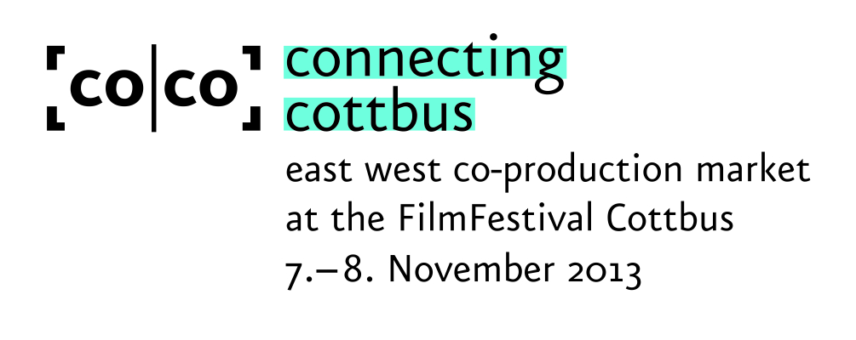

Application for Participation

If you wish to participate at connecting cottbus without presenting your own project, please fill out the complete application form below and send it back latest until 1 October, 2013 to accreditation@connecting-cottbus.de

Date of Arrival ...............................................

Date of Departure ..........................................

PARTICIPANT

Surname (as written in the passport):

First name:

Function/Job/Position:

Freelance (x):

Address/Country:

Phone:

Mobile phone:

Email:

Web:

to be published in the connecting cottbus guide (yes/no):

COMPANY

Name:

Address/Country:

Phone:

Mobile phone:

Email:

Web:

to be published in the connecting cottbus guide (yes/no):

Working Sector (x)

Producers:
Distributors/Sales Agents:
Buyers/Financiers/Investors:
Directors/Authors:
Journalists/Press:
Training/Networking:
Markets/Festivals:
Services:
Marketing:

PROFILE / ACTIVITIES of the company (max. 850 characters)

CURRICULUM VITAE of the participant (max. 850 characters)

Please note: connecting cottbus guide

The “connecting cottbus guide” offers an overview of all participants taking part in the co-production market. Therefore, we kindly ask all guests to please send us a passport photograph.
With your 2013 application form, you agree to the publication of your contact details and your company's profile/activities in the “connecting cottbus guide”. Please note that the application form and the photo must have reached us by email by 1 October, 2013 at the latest. Please send form & photo to accreditation@connecting-cottbus.de

The accreditation and information material are available from 5 November, 2013 at the guest centre.

