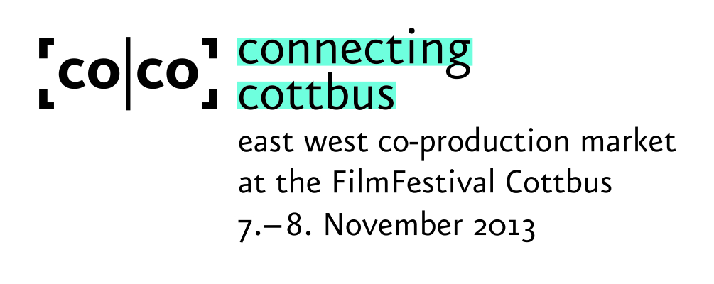

# **Application for participation with a project**

Fill out the complete application form below in word or rtf. Please note that the application must be completed in English. Submit the treatment and script (the latter only if available) as well as a passport sized photograph of the producer and the author or director by e-mail. Please send your **completed application** together with the photographs to [**pitching@connecting-cottbus.de**](mailto:pitching@connecting-cottbus.de) **latest** until **15 July 2013.**

**GENERAL DATA**

Title of the project :

Company :

Country :

Name of producer :

Name of director :

Name of author :

**CONTACT PERSON**

Surname :

First Name :

Position :

Address :

Phone (office) :

Mobile phone :

Email :

Web :

**PRODUCER**

Surname (as written in the passport) :

First Name :

company :

Address (company) :

Phone (office) :

Mobile phone :

Email :

Web :

**DIRECTOR**

Surname (as written in the passport) :

First Name :

Address :

Phone :

Mobile phone :

Email :

Web :

**AUTHOR**

Surname **(as written in the passport)** :

First Name :

Address :

Phone :

Mobile phone :

Email :

Web :

**COMPANY PROFILE / ACTIVITIES** (max. 850 characters)

**FILMOGRAPHY of the production company** (for the last three years)

**DIRECTOR'S CV** (max. 850 characters)

**DIRECTOR'S FILMOGRAPHY** (for the last three years)

**AUTHOR'S CV** (max. 850 characters)

**AUTHOR'S FILMOGRAPHY** (for the last three years)

**PROJECT DATA**

Original title :

Title in English :

Genre :

Cinema (x) :

Television (x) :

Length :

Shooting format (35mm, HD, 16mm, etc.) :

Delivery format :

**FINANCING**

Estimated production costs (Euro) :

Financing already in place (Euros) :

Please specify :

Partners already attached (please name):

**CONTENT**

Summary **(max. 3 lines)** :

Synopsis **(max. 2.200 characters)** :

Treatment **(5-10 pages)** : Please attach.

Script available? : If available, please attach.

No script available (x) :

**NOTES**

Author's or director's note **(max. ½ page)**:

Producer's note **(max. ½ page)** :

**Team** as far as already known

Name of producer :

Name of author :

Name of director :

Other (specify function) :

**INFORMATION ABOUT THE PITCH**

Motivation to present the project at connecting cottbus **(max. 10 lines)**:

What are you looking for in particular? **(max. 10 lines)**:

Did you submit an application (with the same project) to another coproduction market or are you intending to do so?

Yes :

No :

If yes, please specify :

Is/was the project already selected to be part of another coproduction market?

Yes :

No :

If yes, please specify :

**Please note:**

**If your project is selected, you agree to mention connecting cottbus as a supporter in the credits of the film.** The connecting cottbus guide offers an overview of all participants taking part in the co-production market. With your 2013 accreditation application form, you are agreeing to the publication of your contact details and photos as well as your company's profile/activities, CV, filmography, notes, project data and financing information in the connecting cottbus guide and in the connecting cottbus pitch book.